EMBEDDED SYSTEM AND DESIGN
EXPERIMENT NO. 4

APPLIANCE CONTROLLER

Name: Raphael S. Nano

Course/Section: CPE161P / A1

Date of Performance: December 5-6, 2023
Date of Submission: December 8, 2023

Ma'am Cyrel Manlises
Instructor

DISCUSSION

Appliance controllers highlight a wide variety of features, ranging from timers to complex IoT devices capable of managing and optimizing the efficiency of household appliances. As they became an integral component in modern households, appliance controllers augment convenience, along with their ability to promote cost-effectiveness and energy efficiency. Hence, it is important to highlight the capabilities of an appliance controller and their processes of construction in order to further develop its functionality. With that said, an appliance controller system was constructed and replicated using Arduino Uno as the controller and the stepper motor, servo motor, passive buzzer, and LEDs as the devices being controlled.

The objectives of this experiment are as follows:
1. To demonstrate how an appliance controller works in real-time.
2. To be able apply what you have learned in logic circuits and switching theory, microprocessors, and CPE160P.
3. To be able to apply real-time embedded system using Arduino kit.

The materials utilized for this experiment include the Arduino Uno, the infrared remote, TSOP1838 IR receiver sensor, 28BYJ-48 stepper motor, the SG90 servo motor, a passive buzzer, and three (3) LEDs.
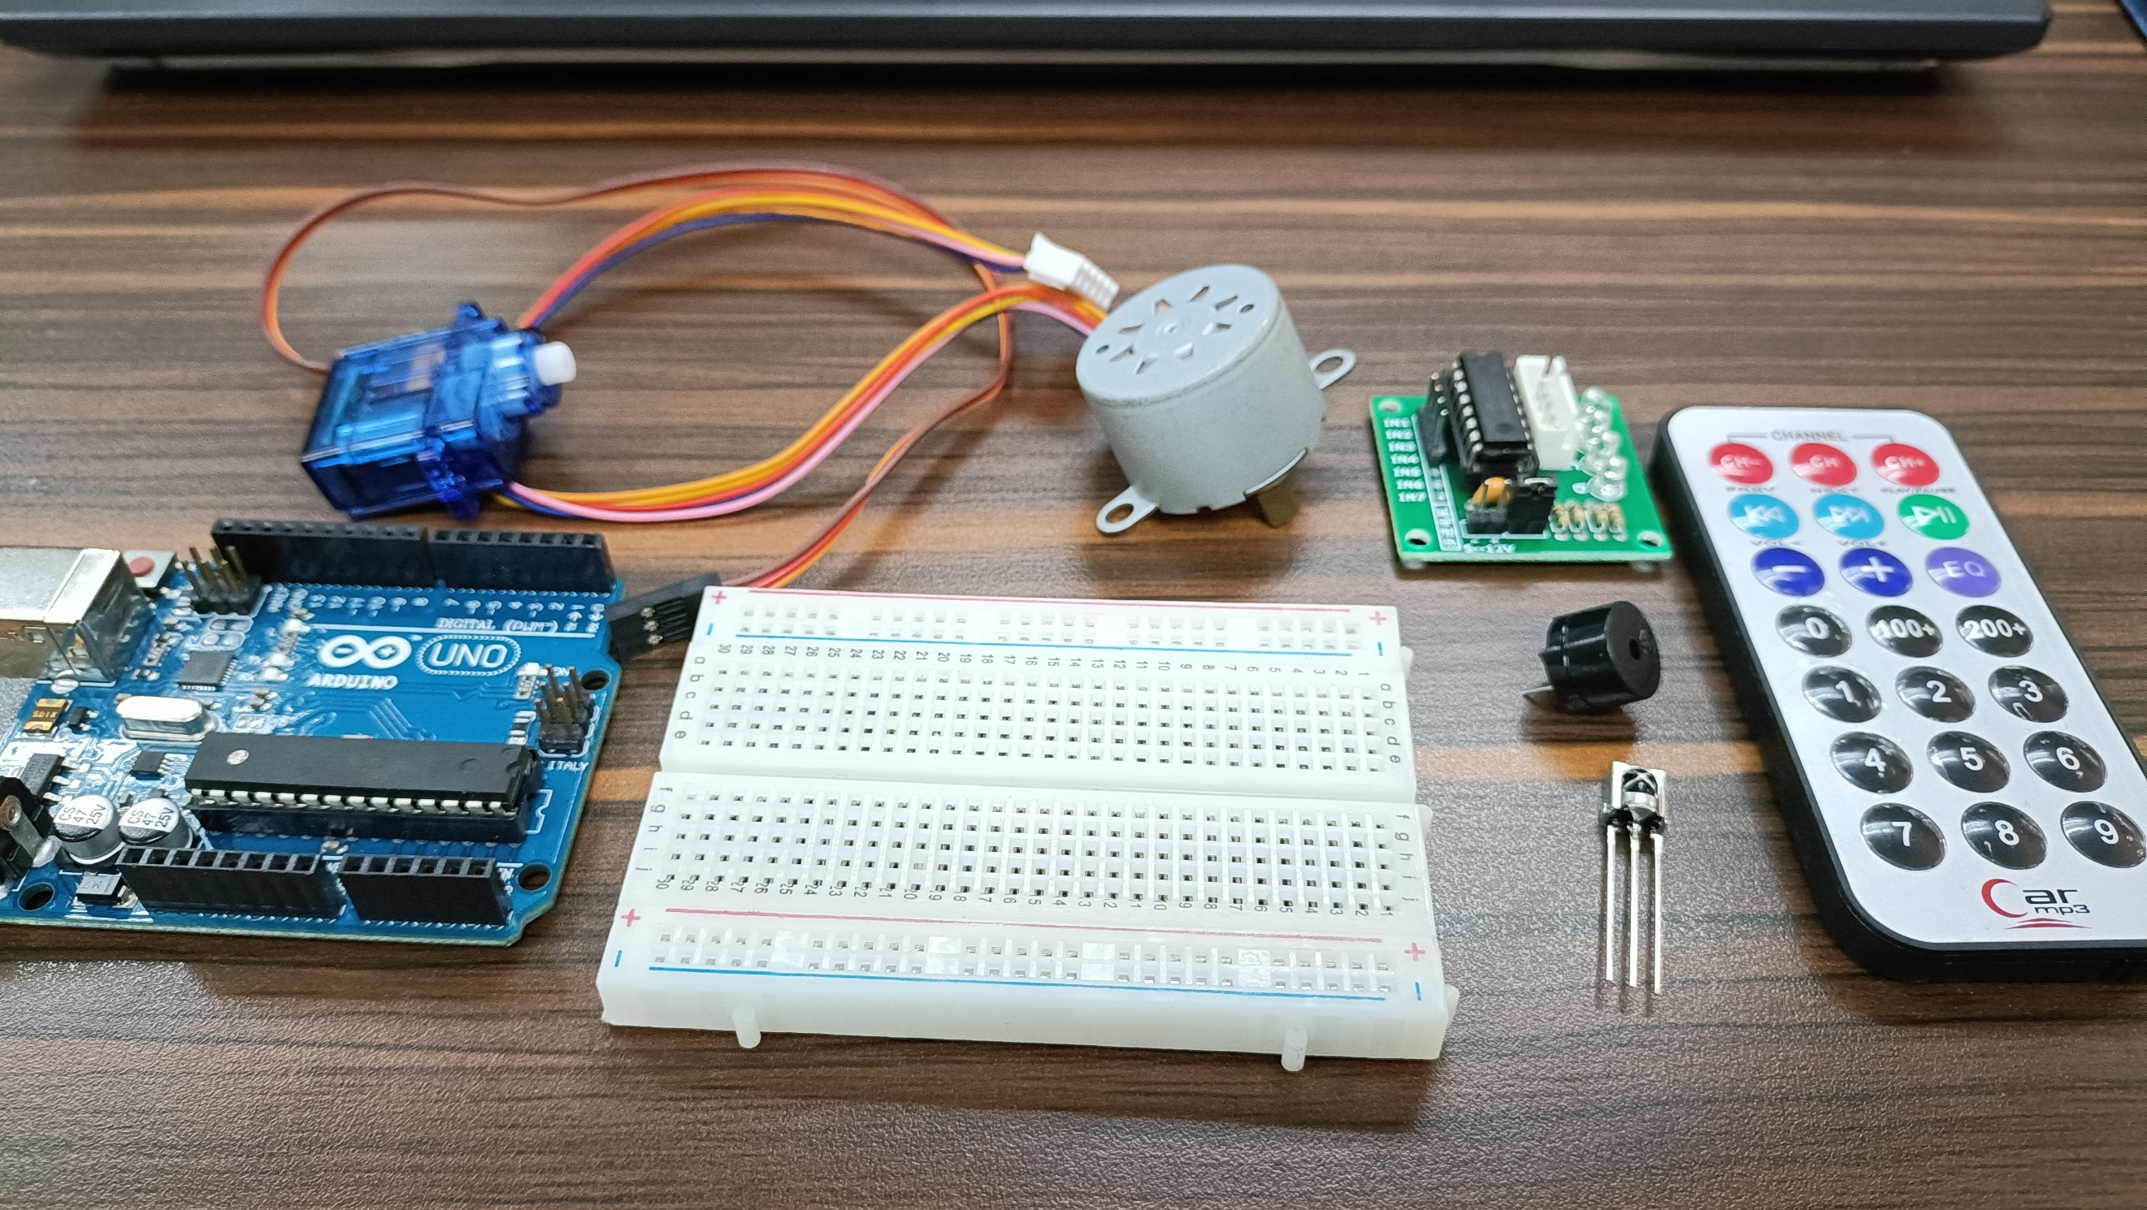

Figure 1. Major Components for the Experiment

For the external libraries, the IRremote.h, Stepper.h, and Servo.h was utilized for the remote, the stepper motor, and the servo motor respectively.
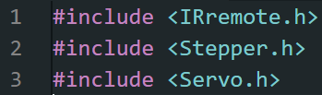

Figure 2. External Libraries Included

The primary objective for experiment 4 is to replicate an application controller that operates in real-time. The IR remote will be used as the controller, wherein it includes the control to every appliance (e.g., stepper motor, servo motor, buzzer, LEDs). The operations simply turns the appliance ON and OFF with the use of the numbers on the remote and the pause/play button.
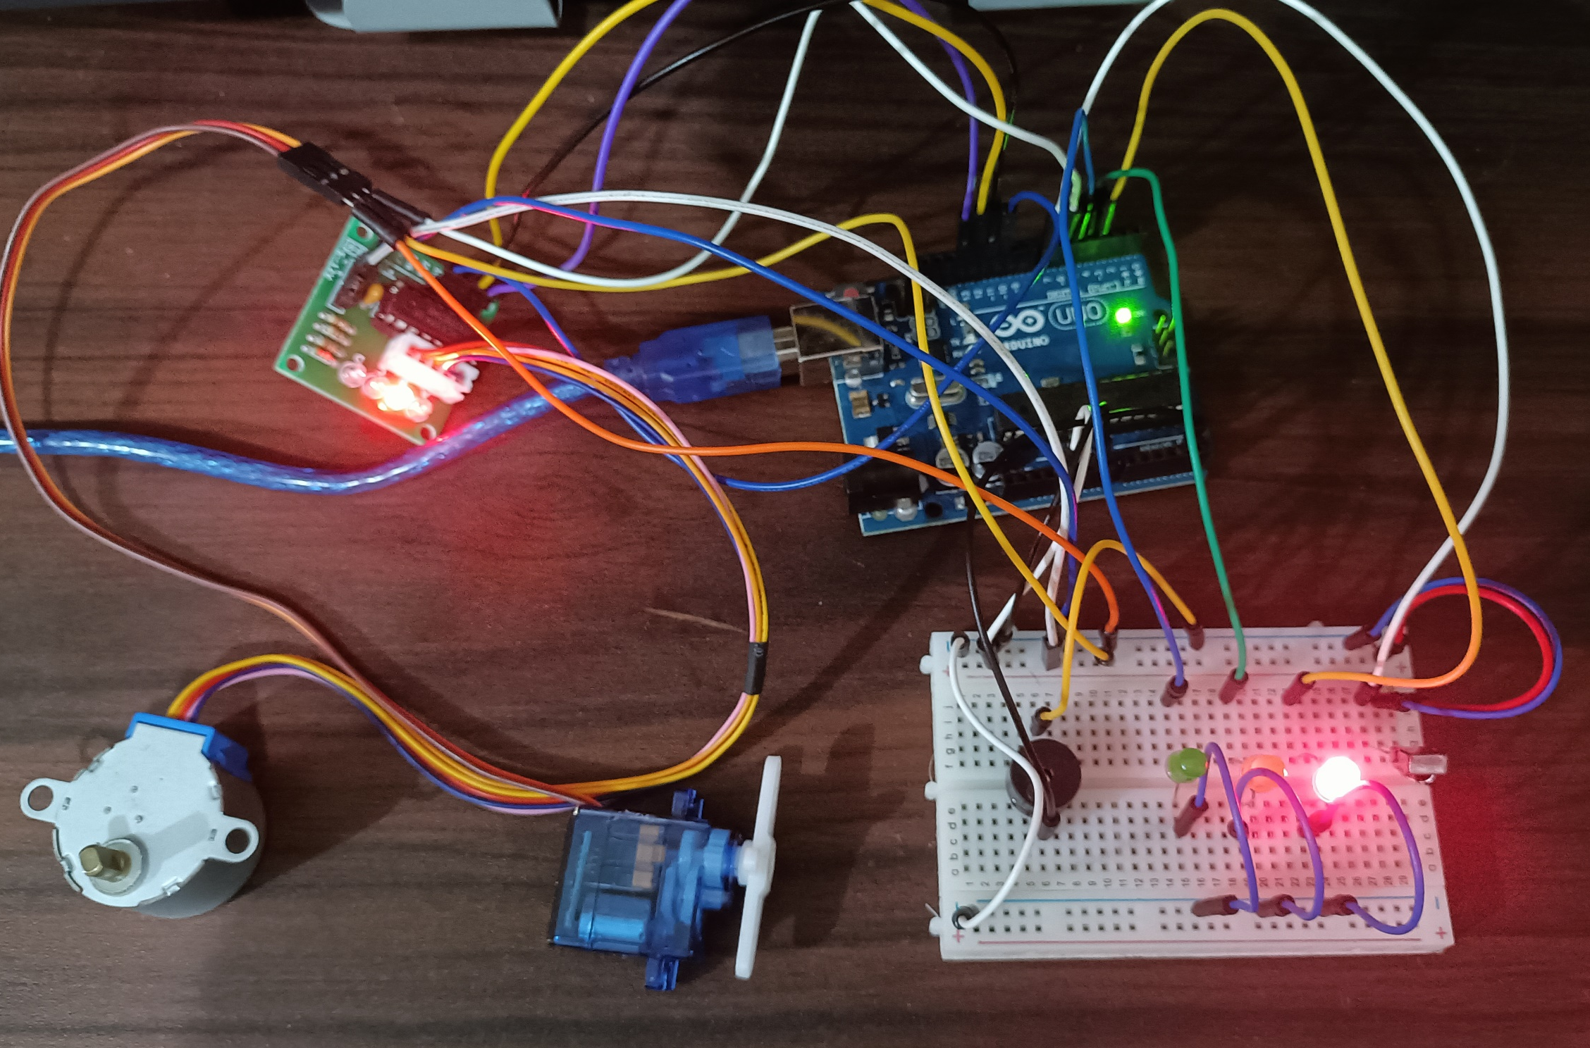

Figure 3. Final Output of the Experiment
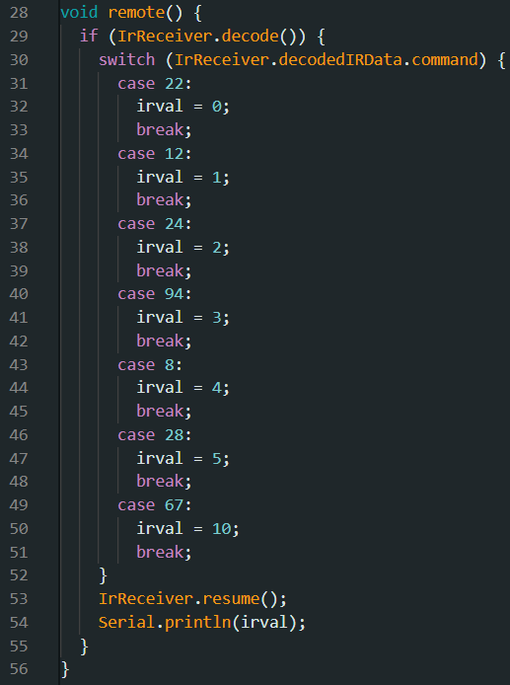
An optimized switch case inside a remote() function was utilized to determine the value of the button pressed in the remote. Using the function IrReceiver.decodeIRData.command, the values were obtained experimentally. For button 0, an integer of 22 is decoded. 12 for button 1, 24 for button 2, 94 for button 3, 8 for button 4, 28 for button 5, and 67 for the pause/play button.

Figure 4. Switch Case for IR receiver
Since button 1 is assigned to the stepper motor, the stepper motor continuously rotates as long as the pause/play button is not yet pressed.
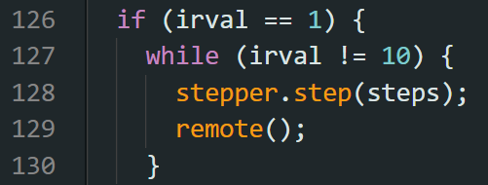

Figure 5. Code for stepper motor

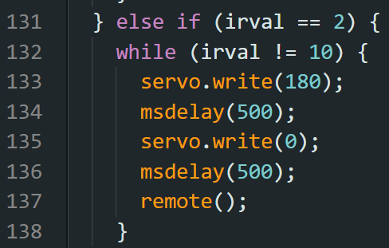
Button 2 is assigned to the servo motor, wherein it writes 180 degrees and 0 degrees every after 500 milliseconds.

Figure 6. Code for servo motor

The passive buzzer is assigned to button 3, and in its code, a separate playTone() function is created.
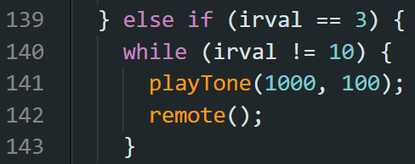

Figure 7. Code for activating passive buzzer
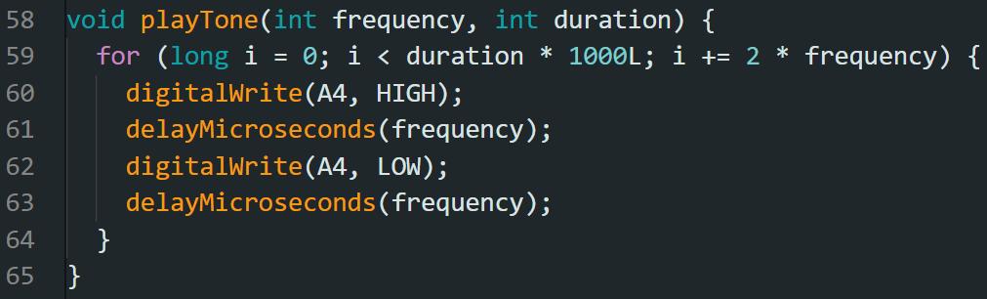
For the passive buzzer, its frequency was controlled and its duration was specified in order to trigger properly. The pin where the buzzer is connected is simply triggered HIGH and LOW in order to turn it ON and OFF, respectively.

Figure 8. playTone() function

For the last component, the LEDs, a pattern of lights was constructed wherein the LEDs turn ON through a process of 1-2-3, ALL-ALL, 3-2-1. It is assigned to button 4.
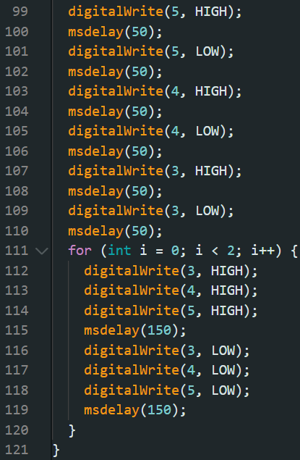
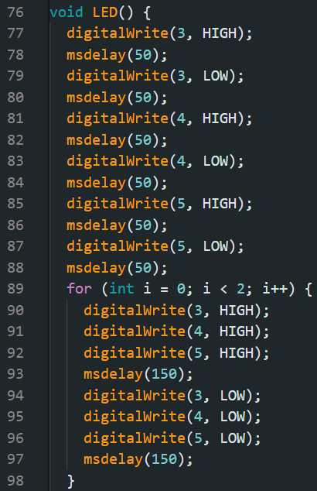

Figure 9. Codes for LED() function
Lastly, to activate all of the components at once, the loop simply contains a repeat of all of the program and codes utilized for each of the components. Button 5 is assigned to the activation of all the components at once.
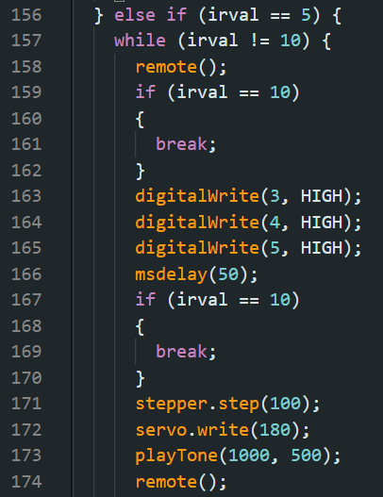
Figure 10. Activation of all Components
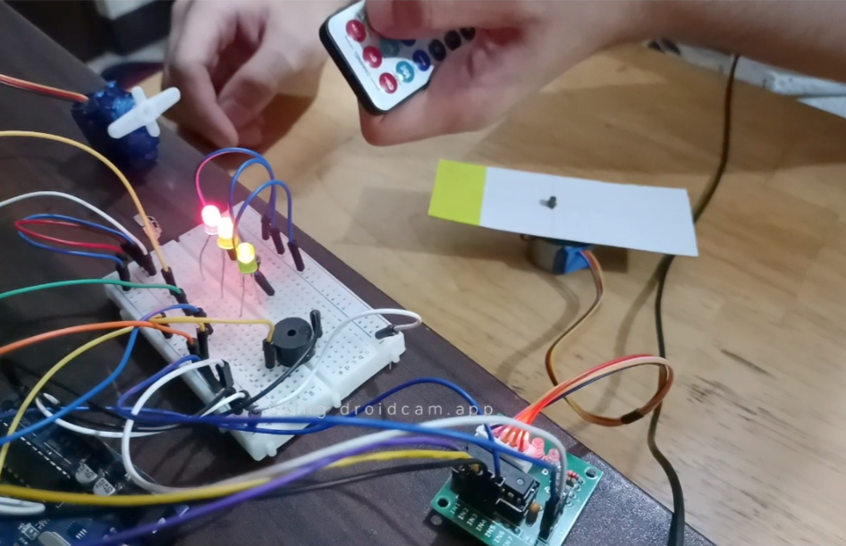
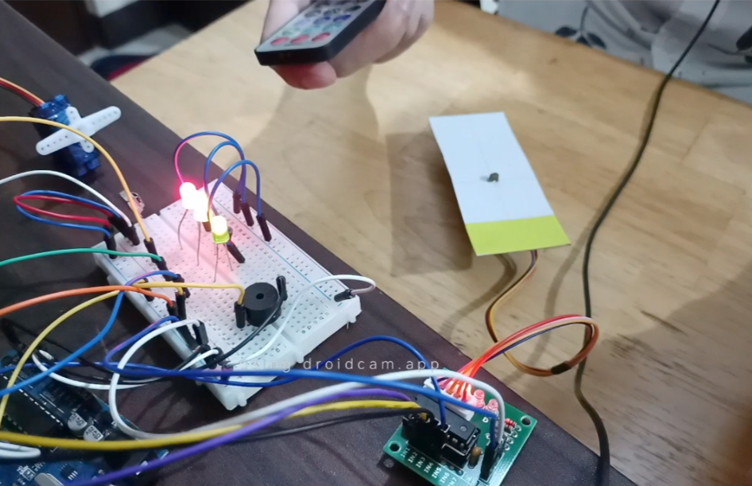
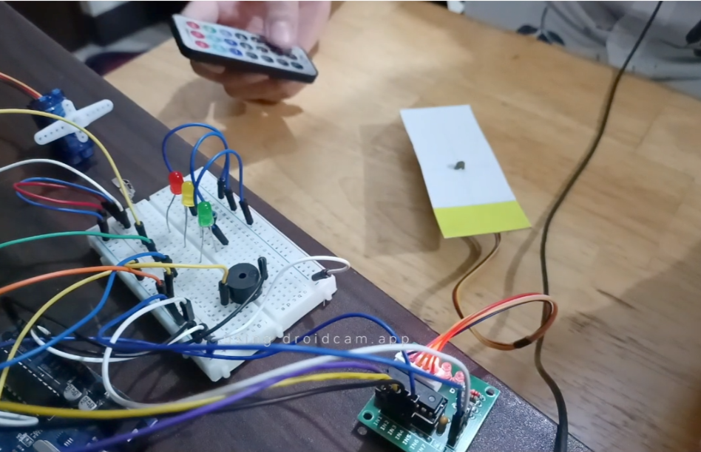
(b)
(a)
(c)
Figure 11. Sample Final Outputs of Experiment 4
CONCLUSION
To conclude, for the first objective, all components are successfully controlled through the use of buttons 1 - 4 for stepper motor, servo motor, buzzer, and LEDs, respectively, and each component can be stopped or reset using the pause/play button. Moreover, an additional function was included, wherein all of them will activate at once using button 5 as the trigger. The usage of microprocessors, logic circuits, and switching theory, as well as the lessons in CPE160P, was shown utilizing series connections, pin layouts, motors, buzzers, and output activation, as the second aim was met. Ultimately, to meet the third goal, the appliance controller was successfully built using the Arduino kit and demonstrated in a basic handshaking by employing various variables, modules, and invoking such functions to develop an embedded system.

